Day 1 – Lab1

1. Create a Database named ShopperStoreDb with the schemas and tables as shown in the database diagram below.

Consider the following points while designing the database and script the respective solutions and answers.

1. Create the schemas
2. Identify the order for creating tables
3. Use proper naming conventions
4. Identify the relationships between tables
5. Apply necessary constraints to columns of the tables
6. Use On delete cascade / set NULL / set DEFAULT wherever applicable
7. Use identity columns for primary keys

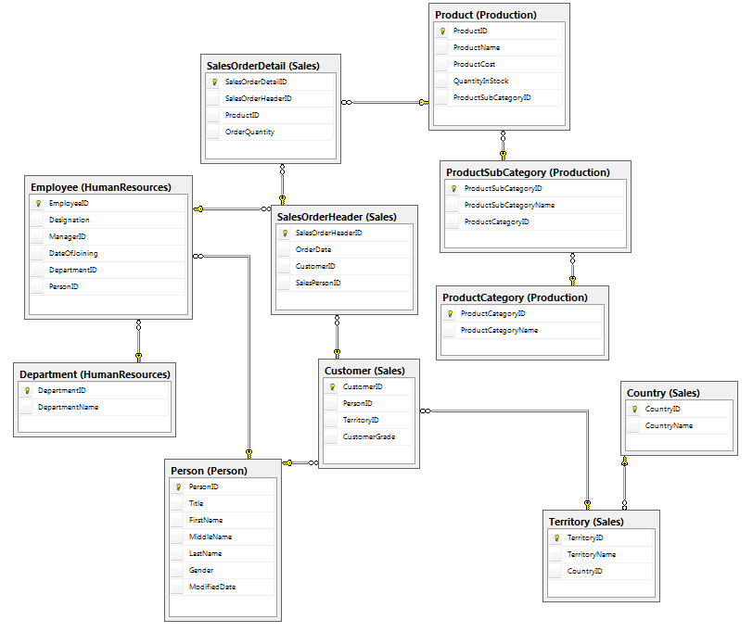

1. Insert records in all the tables
2. Update and increase the cost by 10% for the products starting with name S or A

Day 2 – Lab 2

Lab 2.1: Filtering Data

Use the ShopperStoreDB database to complete this lab.

1. Write a query that displays all the employees listed in the HumanResources.Employee table who have the designation Sales person. Display the Employee ID, the Manager ID, and the designation for each one.

2. Write a query that displays all the names in Person.Person with the middle name P. Display the first, last, and middle names along with the ID.

3. Rewrite the query you wrote in question 1, changing it so that the employees who do not have the

Designation ‘Sales Person’ are displayed.

4. Write a query that displays all the rows from the Person.Person table where the rows were

modified after December 29, 2000 and the persons are Male. Display the Person ID, the name columns, and the modified date.

5. Rewrite the last query so that the rows that were not modified on December 29, 2000, are

displayed.

6. Write a query displaying the order ID, order date, and CustomerID from the Sales.SalesOrderHeader

table. Retrieve only those rows where the order was placed during the month of September 2016

7. Change the query in question 6 so that only the dates between August 27 and September 15, 2016, are retrieved.

8. Write a query displaying the ProductID, Name, and Cost columns from rows in the

Production.Product table. Display only those rows where no Cost has been assigned.

9. Write a query displaying the ProductID, Name, and Cost columns from rows in the

Production.Product table. Display only those rows in which the Cost is not 10000.

10. Write a query displaying ProductID, Name and Cost from the Production.Product

table. Include only those rows where at least one of the ProductName or Cost columns contains

a value.

Lab 2.2: Wild cards

Use the ShopperStoreDB database to complete this lab.

1. Write a query that displays the product ID and name for each product from

Production.Product table with the name starting with *LG*.

2. Write a query like the one in question 1 that displays the products with *-* in the name.

3. Change the last query so that the products without *-* in the name are displayed.

4. Write a query that displays the Person ID number, first name, middle name, and last

name from the Person.Person table for only those rows that have *E* or *B* stored in the middle

name column.

5. Explain the difference between the following two queries:

**SELECT FirstName**

**FROM Person.Person**

**WHERE LastName LIKE 'Ja%es';**

**SELECT FirstName**

**FROM Person.Person**

**WHERE LastName LIKE 'Ja_es';**

Lab 2.3: Group By and Order By

1. Display Title wise count of Persons

2. Display Title wise count of Persons only if count is greater than 5

3. Find the first order placed by any customer

4. Find the first order placed by every customer

5.Find the last order date taken by every sales person

6.Display month wise total orders placed

Lab 3

Lab 3.1 Joins and SubQueries [Use ShopperStoreDB]

1. Display Employee ID, First Name, Last Name of all the employees

2. Display Employee ID, First Name, Last Name of all the employees along with all the persons

3. Find the names of customers in India

4. Find the customer name, Order Date, Territory Name and Country Name for the orders placed in India

5. Find the names of sales persons who have taken order in month of September

6. Get the names of all products ordered in sales order header number SO1 and SO2

Lab 4

1. Create a procedure to update the product with a new name in Production.Product table for a given product id only if cost of product cost is greater than 100
2. Implement the scenario in question 1 through trigger
3. Create a trigger to restrict user from dropping a table and stored procedure.
4. Display the CustomerID, SalesOrderID, and OrderDate for each Sales.SalesOrderHeader row as long as the customer has placed at least five orders. Use any of the techniques including CTE from this section to come up with the query. (Use AdventureWorks2012 database)
5. Create the Patient table in the script below and insert few records

Create Table Patient

(

PatientID Int Identity(1,1) Primary Key,

PatientFirstName varchar(20) Not Null,

PatientMiddleName varchar(20),

PatientLastName varchar(20) Not Null,

Gender varchar(20) Check (Gender IN(‘MALE’,’FEMALE’)),

BirthDate DateTime Not Null

);

Create a Trigger that tracks and logs any update operation on the above table. The log is saved in the table mentioned in the script below

CREATE TABLE PatientUpdateLog

(

UpdateLogID int identity(1,1) primary key,

UpdatedColumn varchar(20),

OldValue varchar(50),

NewValue varchar(50),

ModifiedFromIP varchar(50),

ModifiedDate datetime

)

Lab 5

Top N Analysis

1. Display the 3rd joined employee (Use ShopperStoreDb)
2. Display the customer who has placed 2nd highest orders (Use ShopperStoreDb or AdventureWorks2012)

Note: Other than the questions above request you to practice ranking functions and Over clause on any one table from adventureworks2012 database.